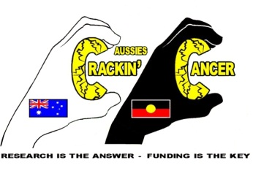

CRACKIN’ CANCER/THREE WATERS, Glen Innes TRAIL RIDE 2015

REGISTRATION FORM

**This event will be held at the Three Waters High Country Holidays site on Bullock Mountain, Glen Innes, NSW 2370**

**NAME:**

**ADDRESS:**

**PHONE: EMAIL**

**IN CASE OF EMERGENCY, PLEASE CONTACT:**

**Name Phone**

**Is there more than one family member on the ride? YES 🞏 NO🞏**

**WHEN COMPLETED PLEASE POST THIS FORM TO CRACKIN’ CANCER: President: Marshall Fittler, PO Box 4323, GOONELLABAH, NSW 2480 OR the Secretary, Bev Stanton at 102 Hotham Street, CASINO, NSW 2470 or with your Cheque/Money Order OR pay by Internet transfer to Westpac Bank BSB 032 539 Account 373 835 with “Three Waters” as the reference.**

**I HAVE READ & UNDERSTOOD THE TWO PAGES OF CONDITIONS/INFORMATION FROM CRACKIN’ CANCER AND WILL COMPLY WITH THESE AND THE CRACKIN’ CANCER-CANCER CODE OF CONDUCT.**

**SIGNED: DATE:**

**Please return this form as soon as possible to allow notification for the catering numbers for the Welcome and Farewell Dinners**

**Any queries please phone Crackin Cancer President, Marshall Fittler on 0411 840 797**

**or the Secretary Bev Stanton on 0433 960 332 – 02 6662 5902**

MC900056461[1]